  POE Part 2 | Keabetswe Matabo Malatje (ST10474900)  Web Development

Question 2
2.1
Booking HTML Page
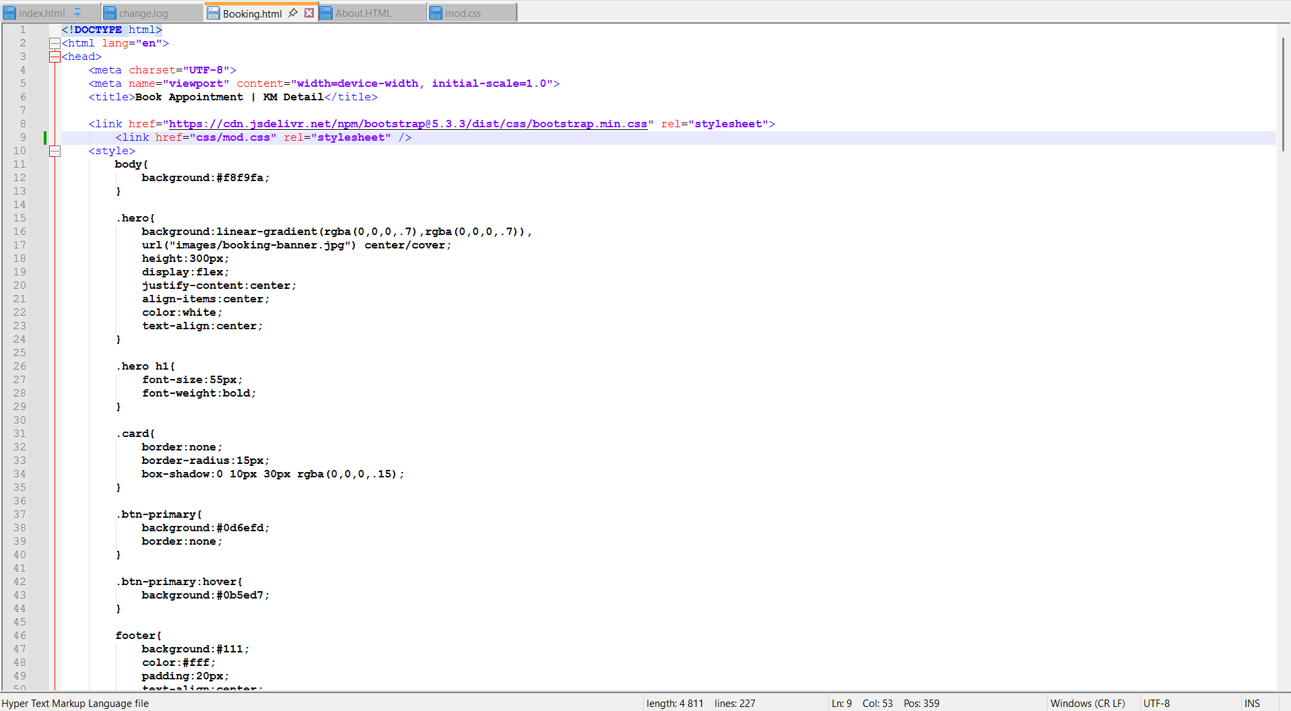
About HTML Page
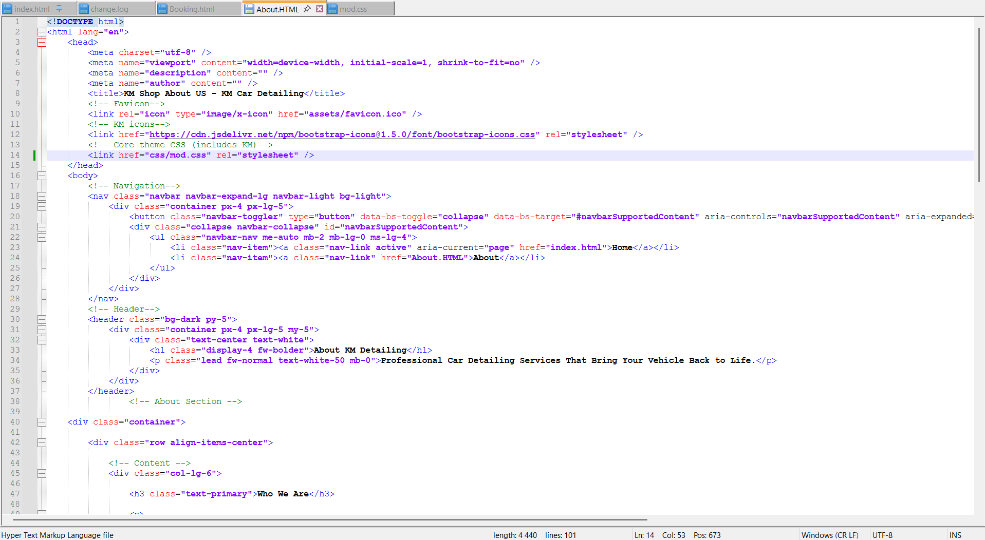

Index HTML Page
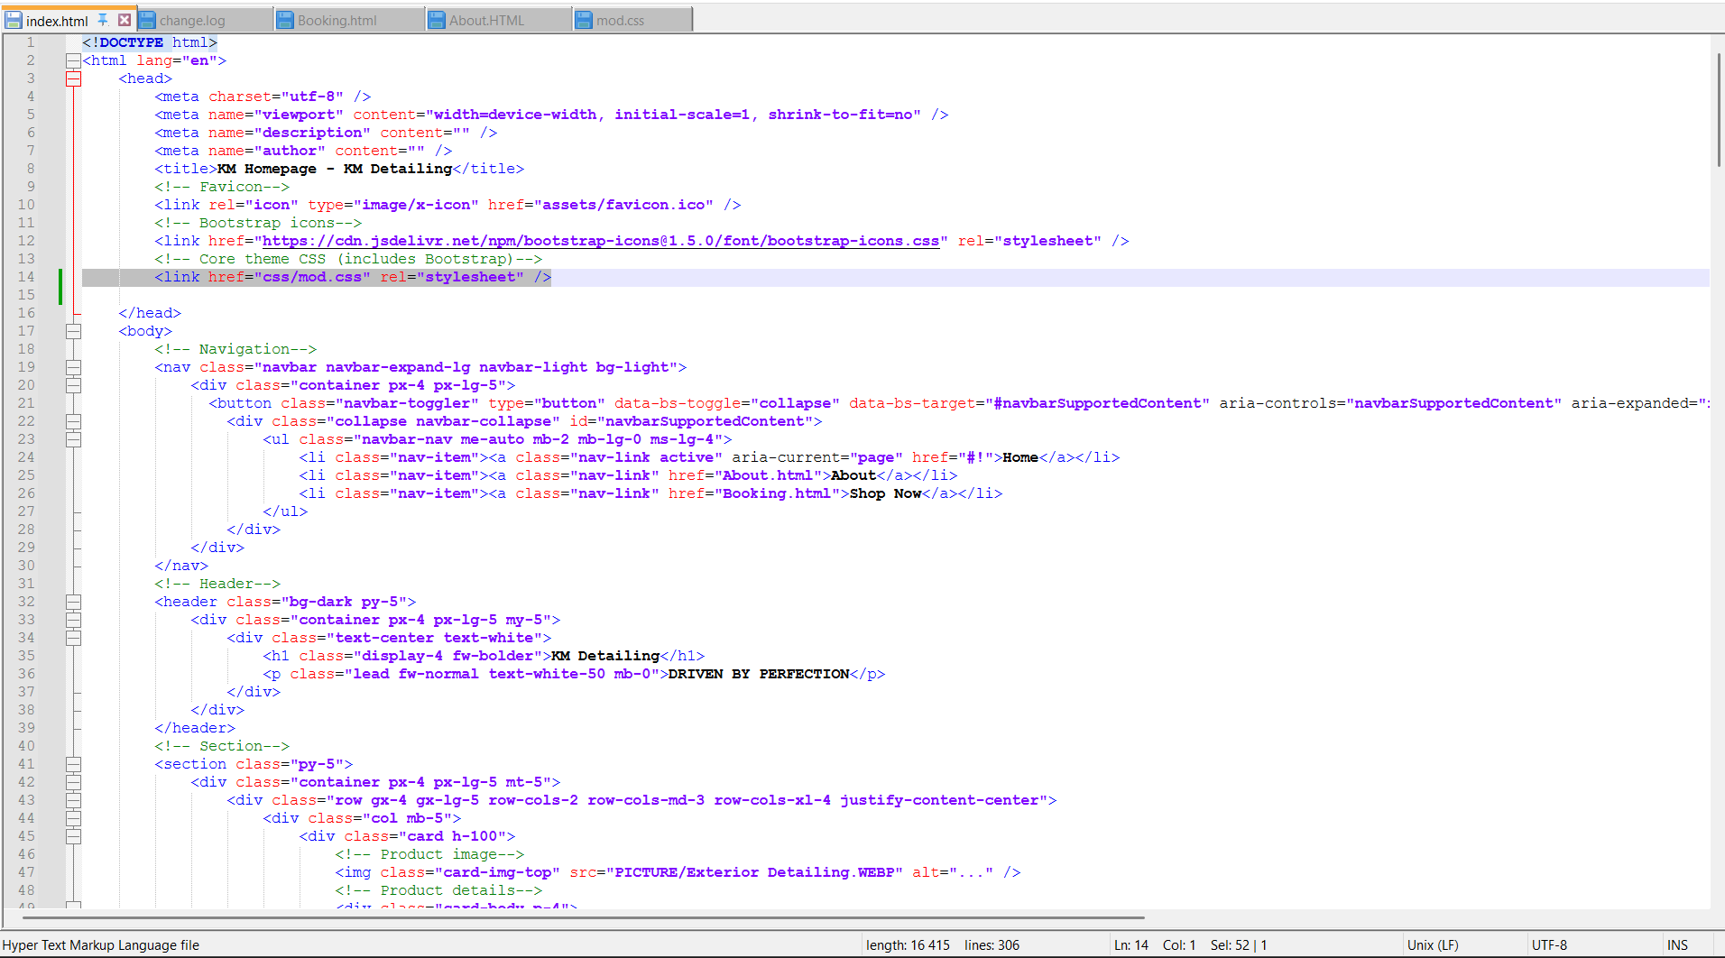

2.2 The base styling was set using the external stylesheet, style.css. The universal selector was employed to remove the default margins and padding, as well as set the box-sizing to border-box. The default body font, font size, line-height, text colour, and background colour were defined. Image styling was also employed to ensure images did not overflow the containing elements. Uniform spacing was provided for the headings and paragraphs, as well as buttons.
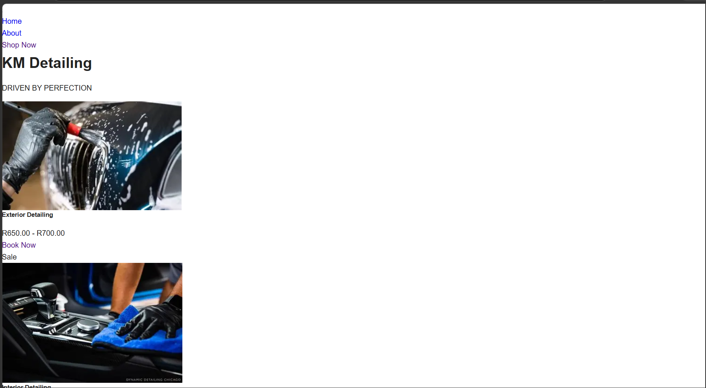
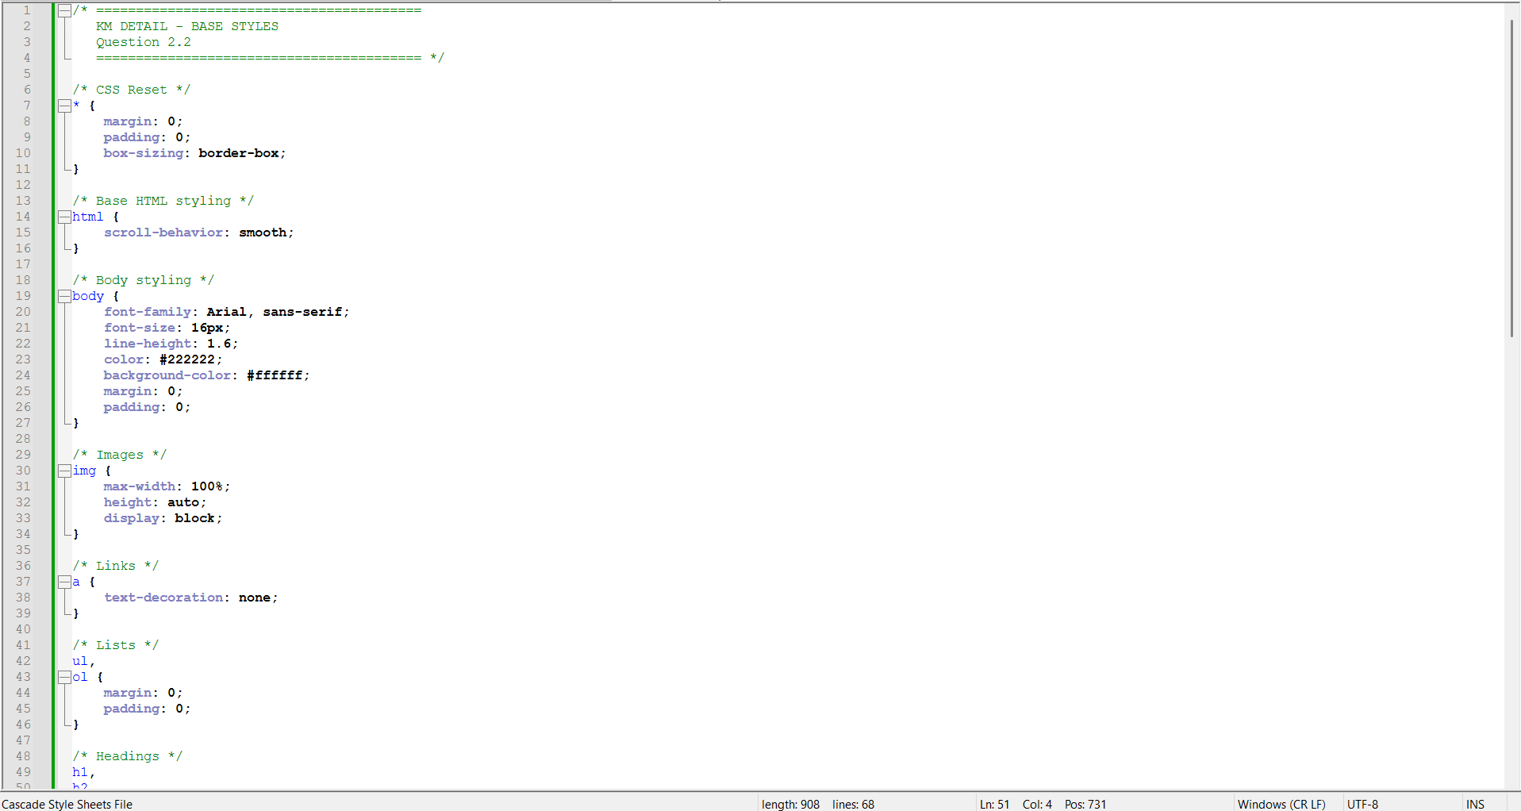

2.3Apply Typography Styles
Typography was applied to the KM Detail website through an external CSS sheet. The heading and website branding fonts were Poppins, whereas Open Sans fonts were applied to regular text, navigation, and buttons. The fonts were also given different weights and sizes to create hierarchy among headings. Line-height and paragraph spacing were also altered to give it a professional look.
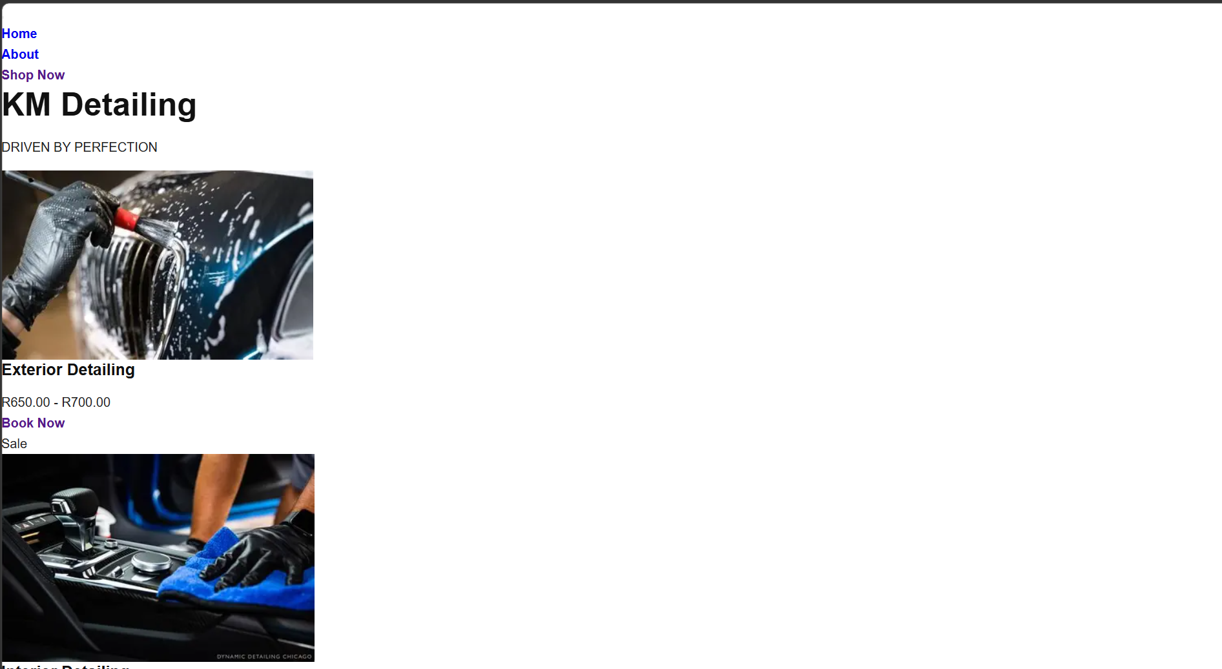
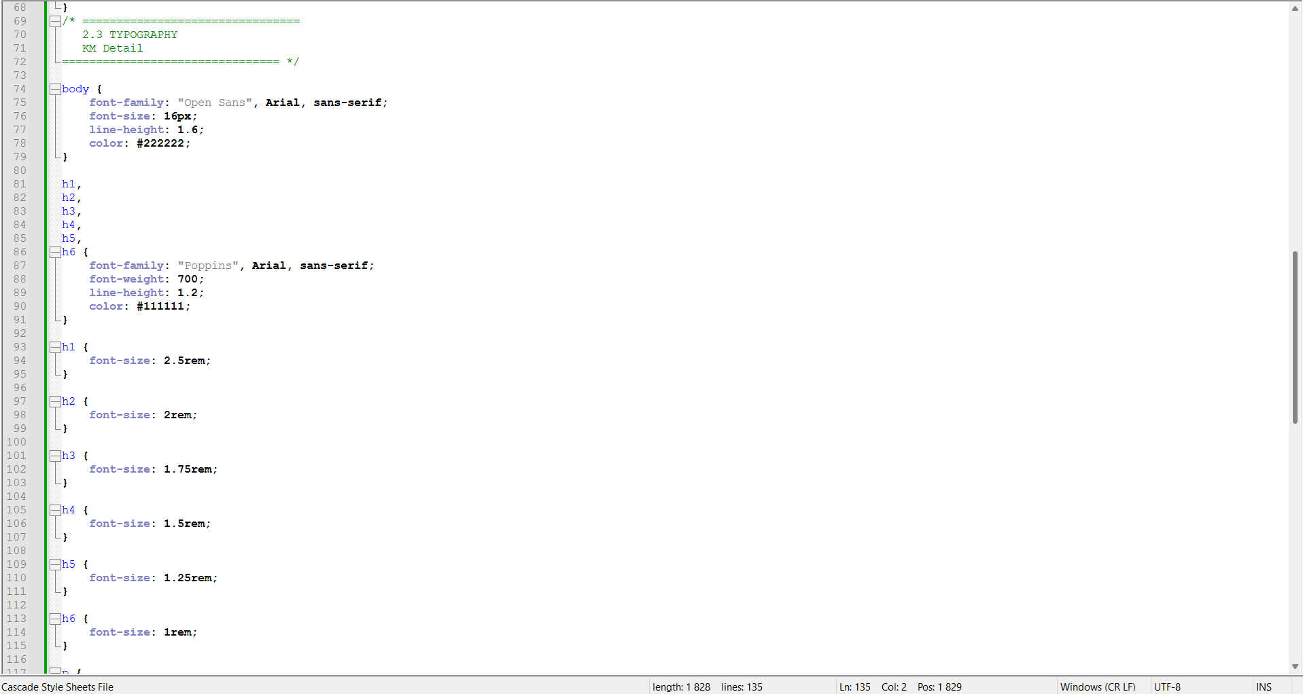

2.4Implement Layout
The design of the KM Detail website was done using Bootstrap's responsive grid system along with CSS Flexbox and Grid. CSS Flexbox is used for the placement of content items like the service cards and footer section whereas CSS Grid was used for the placement of gallery pictures. The use of flex-wrap will make sure that the content shifts to a new line whenever the screen size is reduced. This is also done through media queries for tablet and mobile screen sizes.
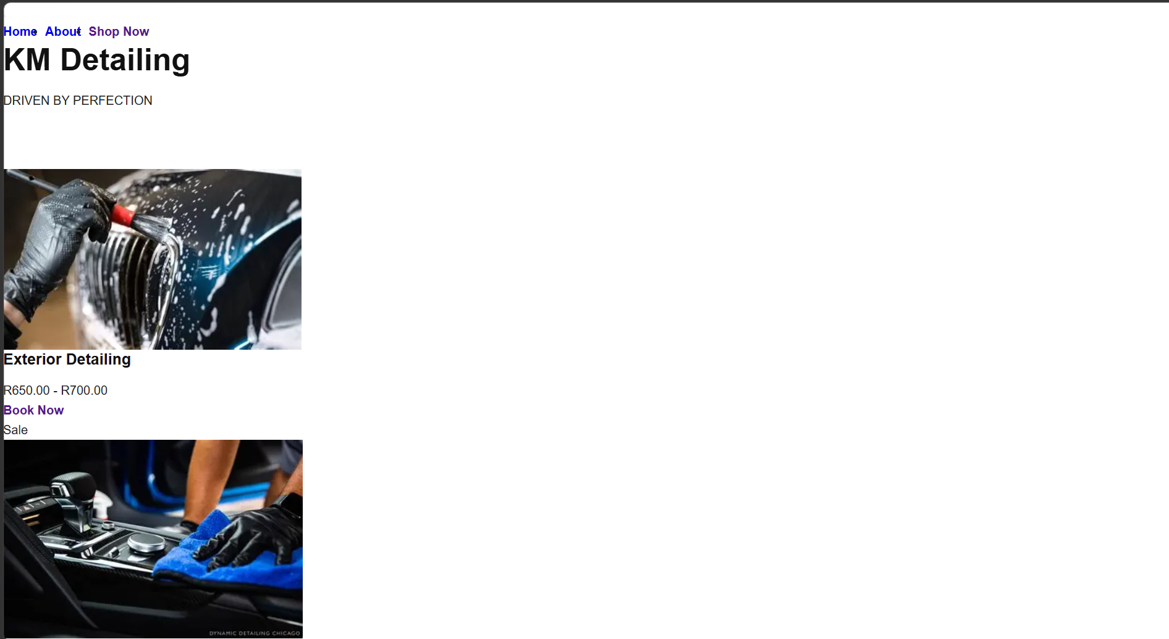
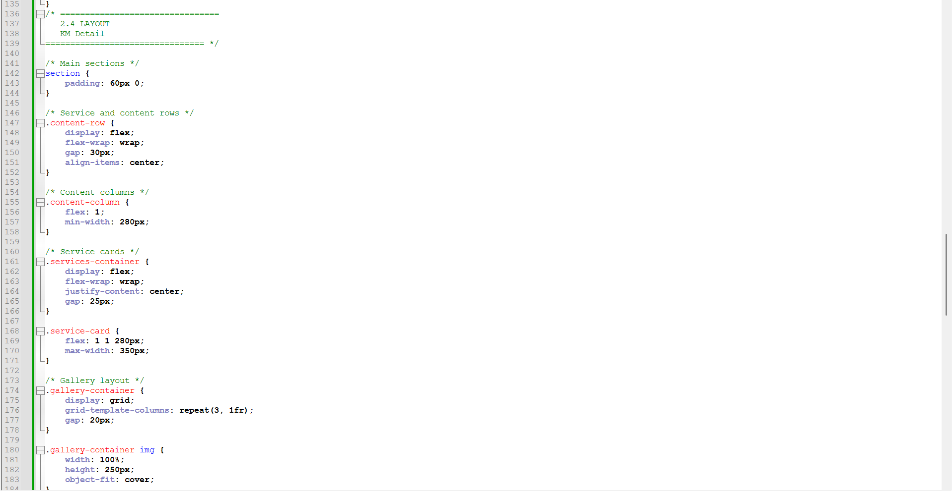

2.5Apply Visual Styles
Different visual styles were employed to the KM Detail website using CSS. This was achieved using a black, white, silver, and blue colour combination to give an automotive design. Different colours, borders, rounded corners, and shadows have been used on different elements of the website. Hover effects have been employed on navigation links, buttons, cards, and gallery images to improve user interface. The form control elements have been highlighted by using focus style, while navigation links use the active style.
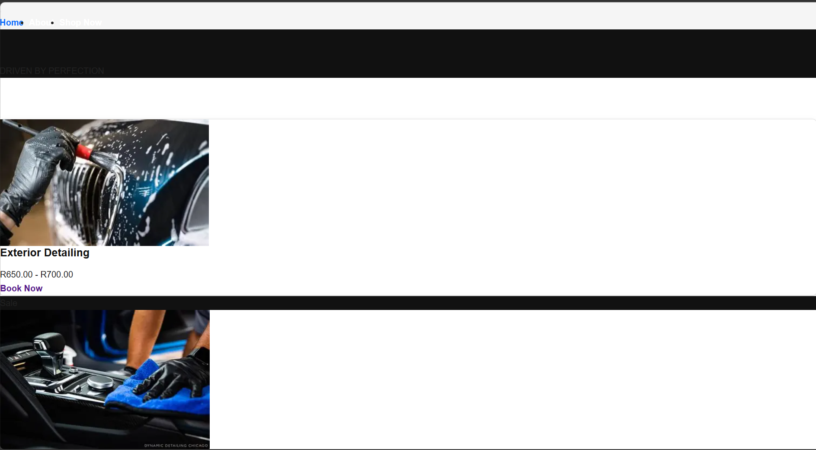
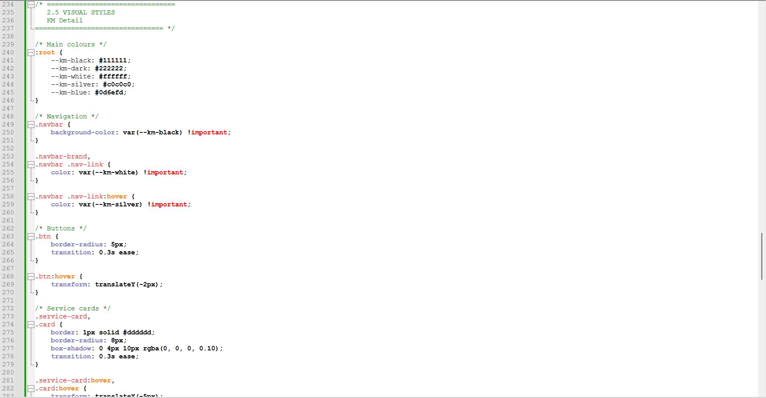

Question 3
3.1Responsive Design
Responsive design was included in the KM Detail website to make sure that the website fits properly on both desktop, tablets, and mobiles. CSS Media Queries were used to make sure that the website adjusts itself based on the screen size. Gallery is arranged in three columns on desktop, two columns on tablet, and one column on mobile devices. Service Cards and other content blocks are re-arranged to fit the smaller screen. Images were resized using responsive image properties.
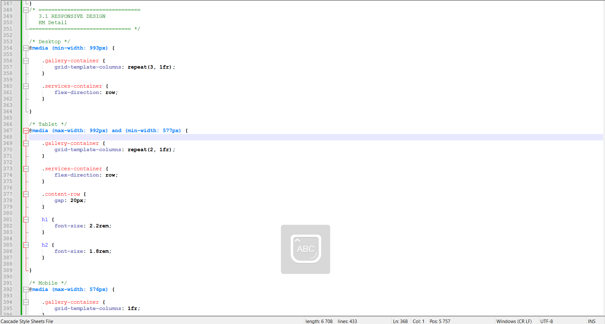

Mobile Display
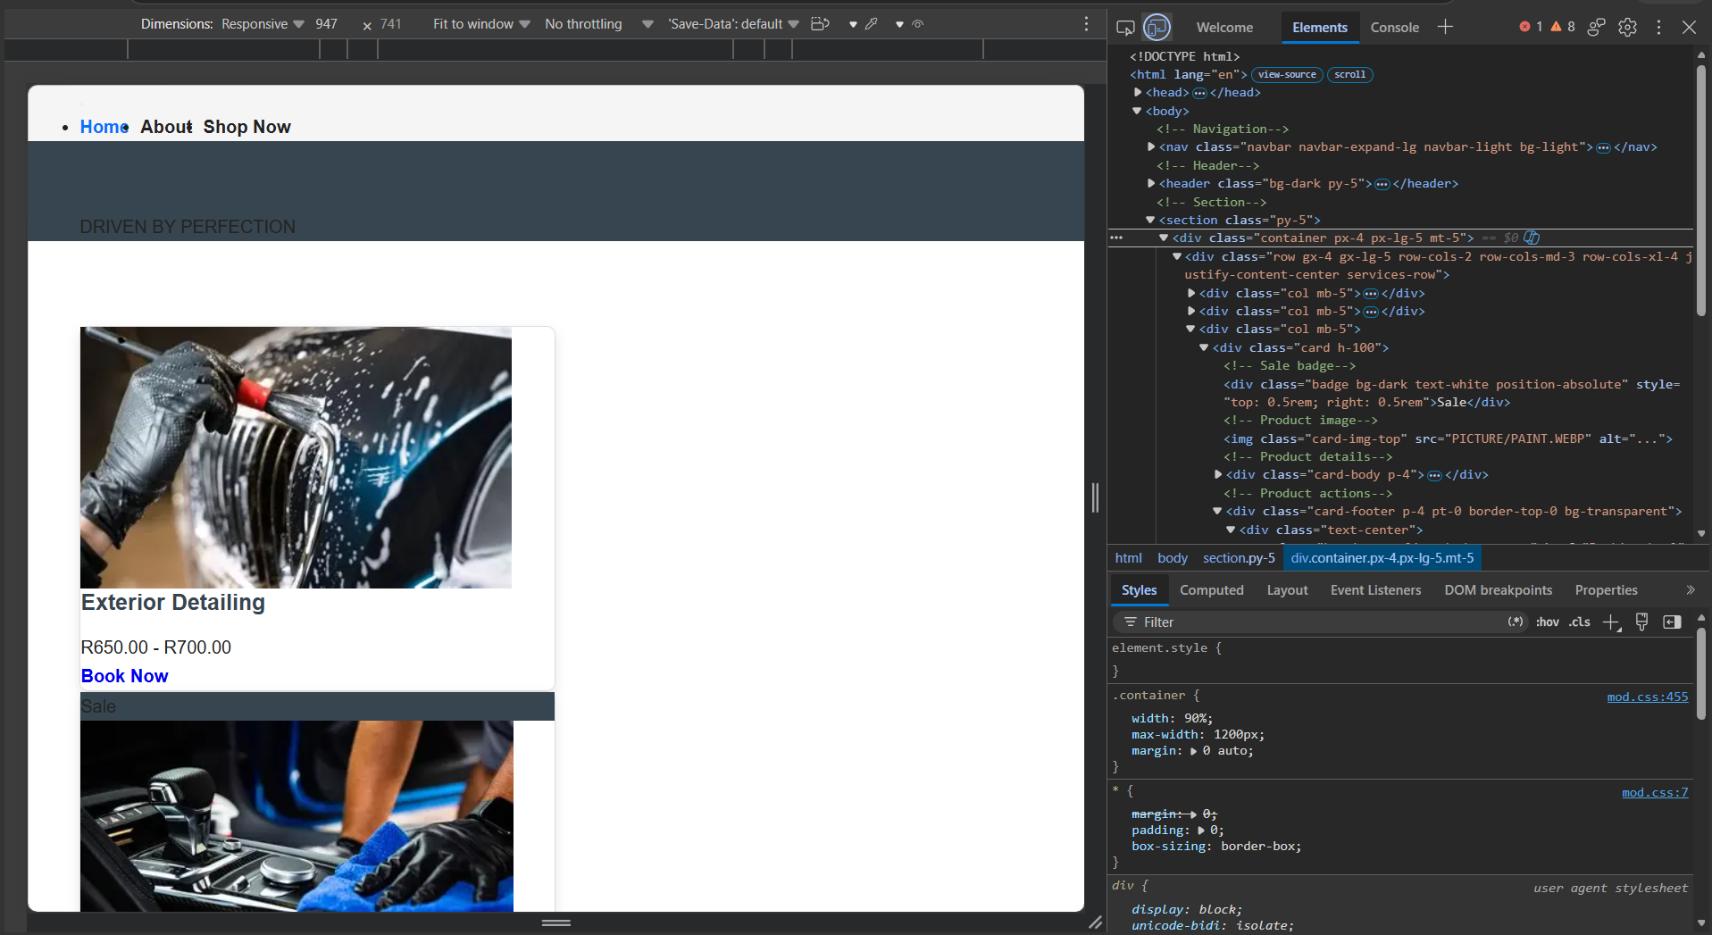
Laptop Display
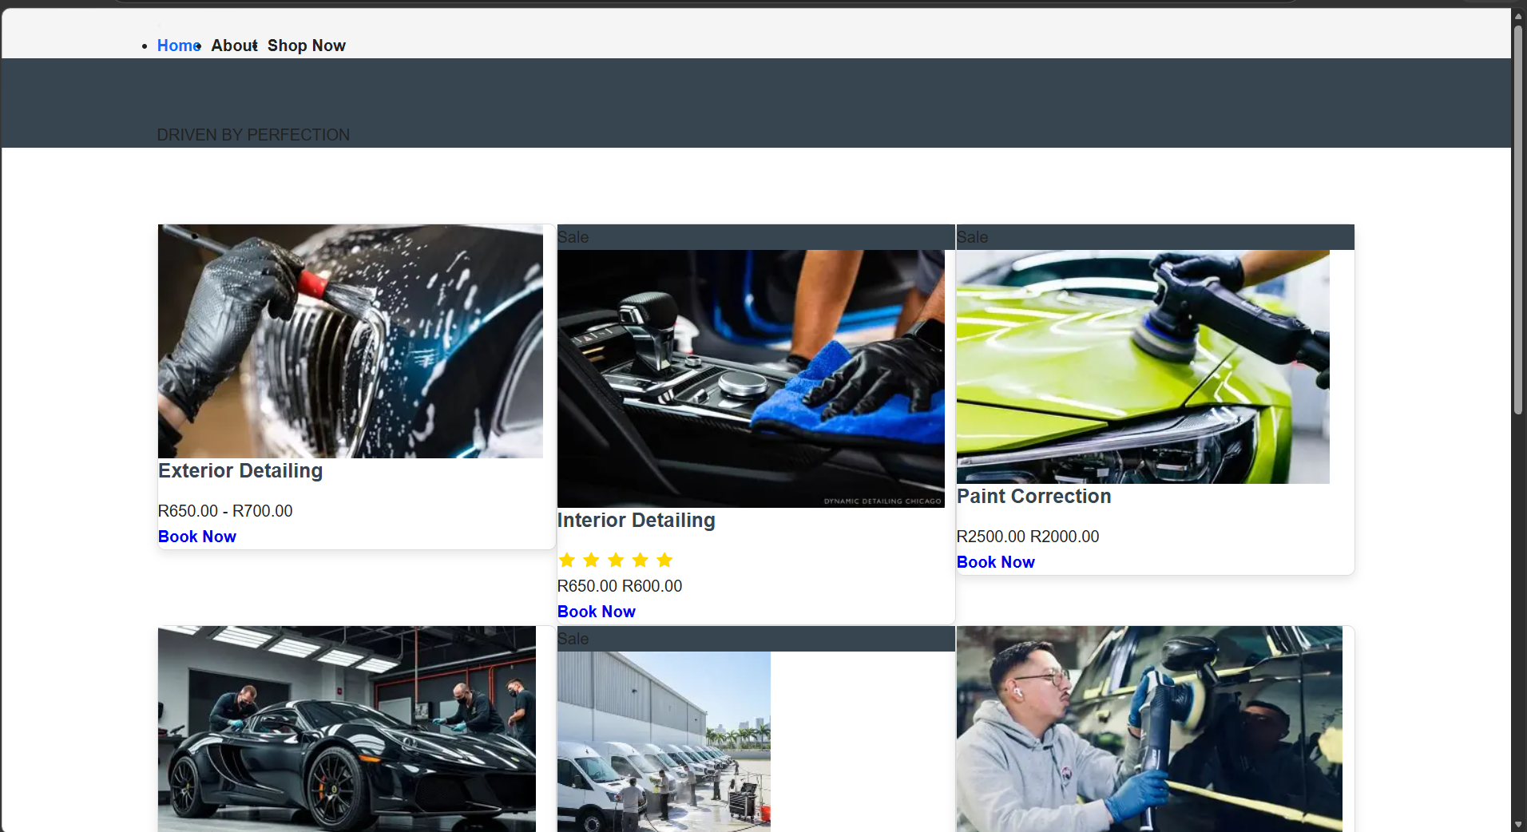

3.2Use Relative Units
Relative units have been employed on the KM Detail website to ensure the website content remains responsive to different screen sizes. Relative units such as rem units have been used in the case of fonts, and in the case of boxes, images, and columns, relative units have been employed in terms of percentages. In addition, the max-width property has been used to avoid making the content too wide.
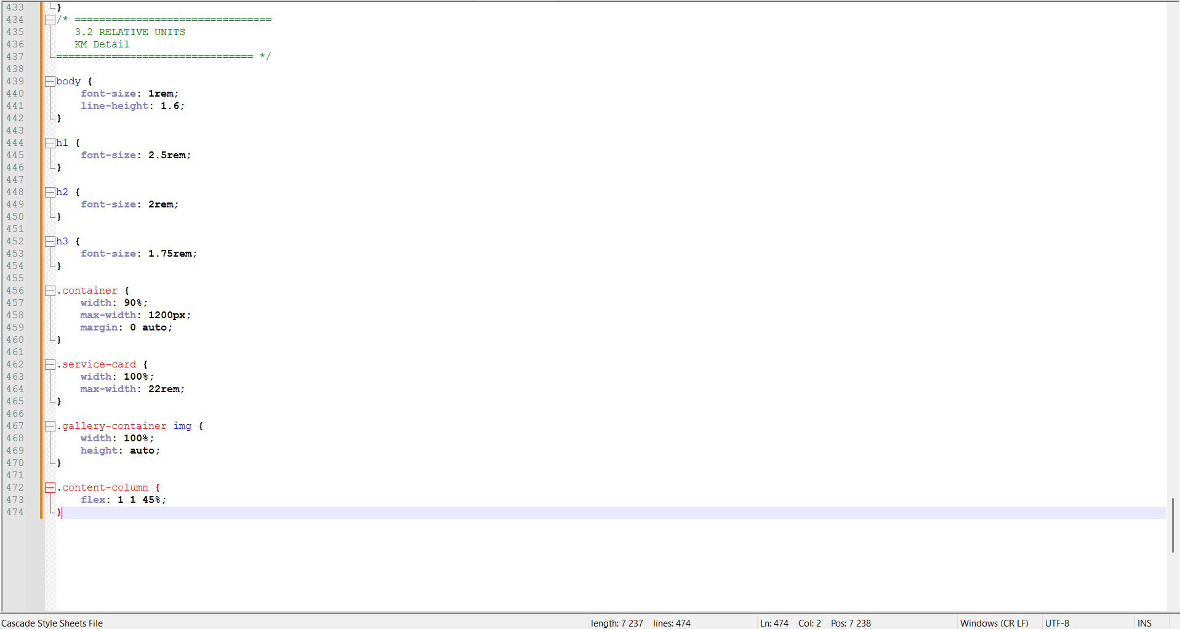

3.3Responsive Images
Responsive styling for images has been applied to the KM Detail website to make sure that images look appropriate on all screen sizes. This has been done using max width: 100% and height: auto so that the images do not overflow and keep their proportions intact. Images in the gallery and service have also been made responsive.
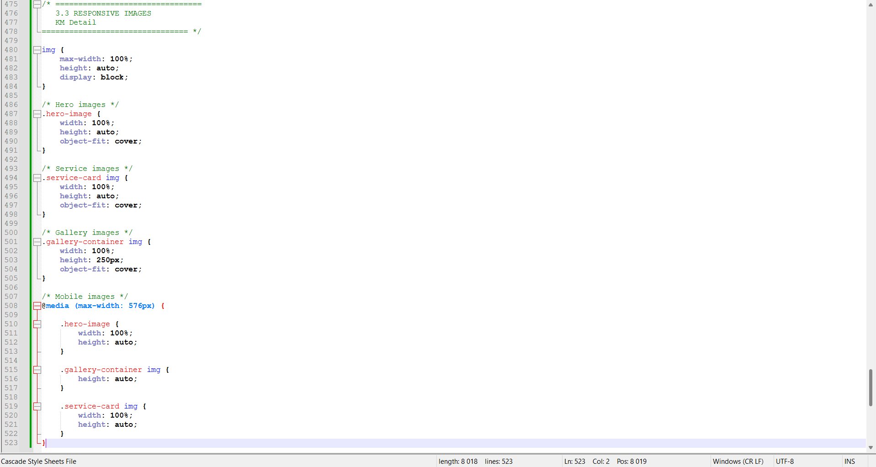

3.4Testing Different Screen Sizes
The KM Detail website was also tested using different screen sizes for desktop, tablet, and mobile screens to ensure that its responsive design works well. Navigation, pictures, services, gallery, appointment booking form, buttons, and the footer were all tested using different screen sizes. Other tests included testing the website for readability, proper placement of the different elements, and unintended horizontal scrolling.
Laptop Testing
